USER GUIDE
Introduction
- This User Guide explains how users can easily access and use the Origami Hub website. The purpose of this guide is to help users explore origami categories, view designs, and navigate the website without any difficulty.
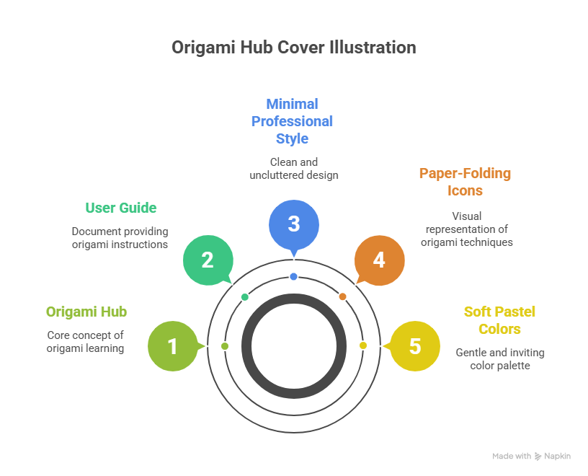

Team Members
- This project, Origami Hub, is the result of the collaborative efforts of a dedicated and skilled team. Each member contributed their knowledge and creativity to ensure the successful development and completion of the project.

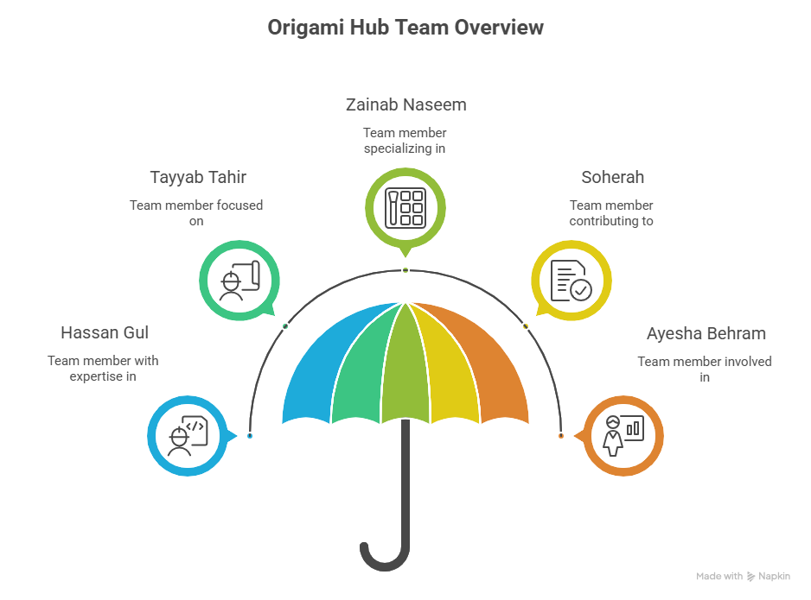

System Overview
- Origami Hub is a user-friendly web application that provides a collection of origami designs. The system allows users to browse different categories and view origami images in an organized gallery format.


System Requirements
- To use Origami Hub smoothly, users need a device with an internet connection and a modern web browser such as Google Chrome or Microsoft Edge

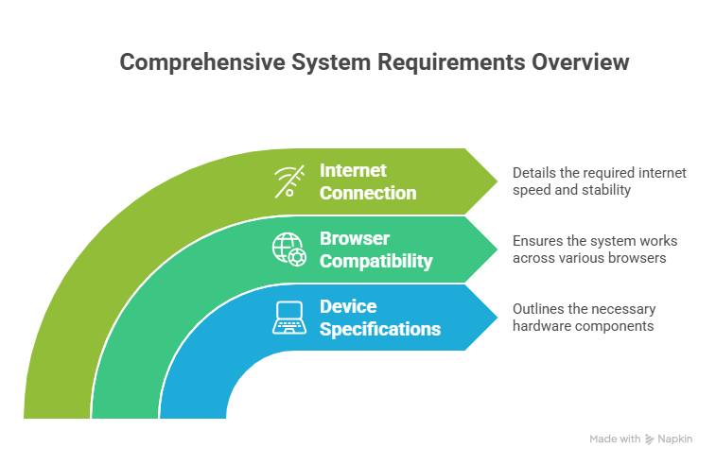
How to Access Origami Hub
- Users can access Origami Hub by opening a web browser, entering the website URL, and navigating to the home page.

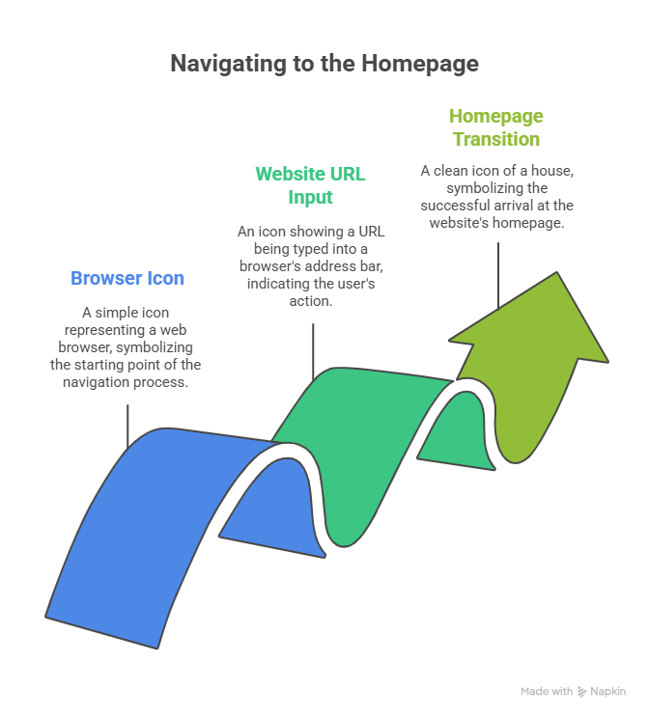
Home Page
- The Home page introduces the website and displays highlighted origami content. It also provides easy navigation to other sections of the website.

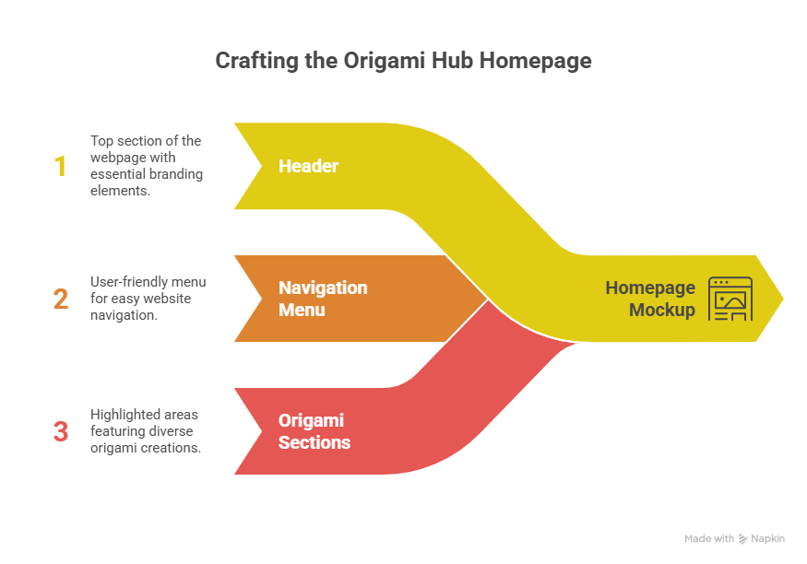
Origami Categories
- This section displays different origami categories such as animals, flowers, birds, and decorative models. Users can select any category to view related designs.
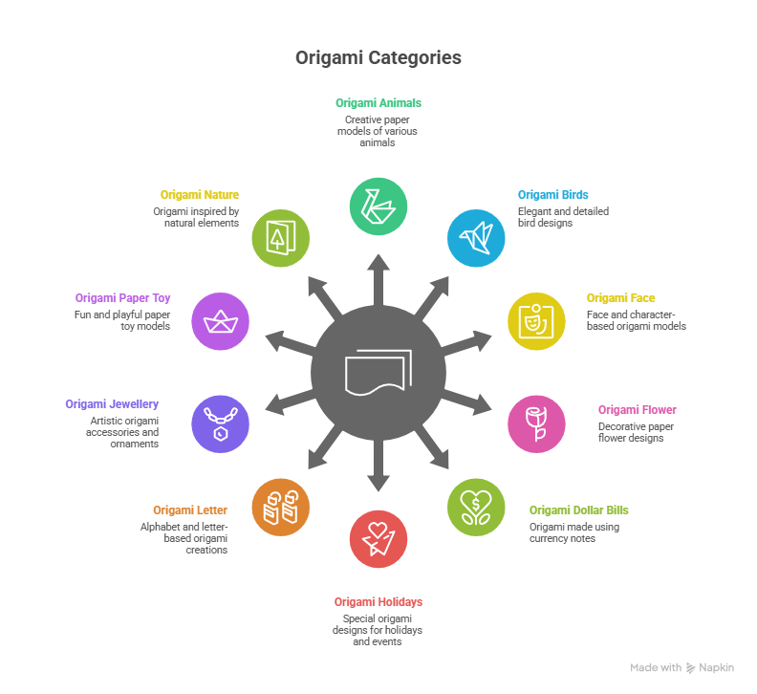
Origami Gallery
- The gallery shows high-quality origami images arranged in an organized layout. Users can scroll through the gallery to explore various designs.

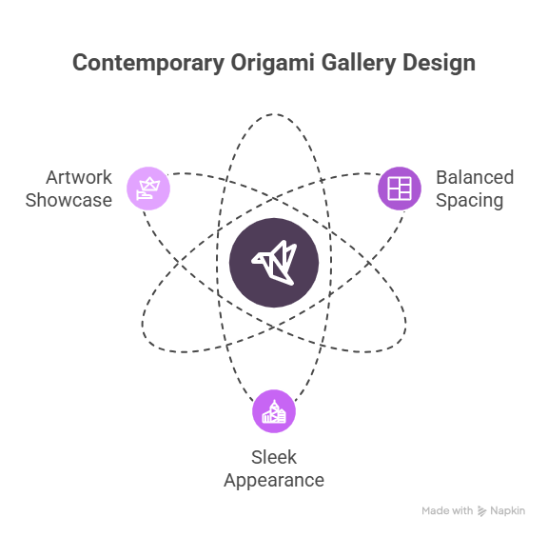
Navigation System
- Origami Hub provides simple navigation that allows users to move between pages smoothly using the menu bar.

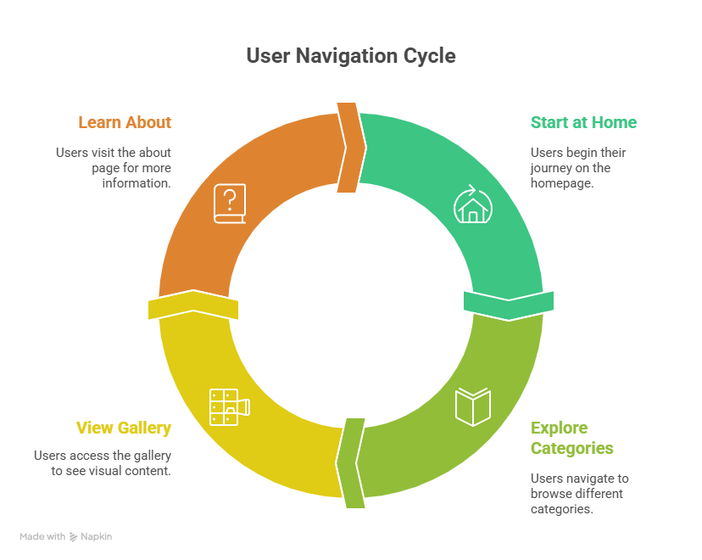
Conclusion
- This User Guide helps users understand how to use Origami Hub efficiently and enjoy exploring origami designs.


